

Portfolio review
The current portfolio's top five positions account for 100% and have substantial influence on portfolio outcomes.
Measure | Current | Proposed | Change
Volatility | 22.9% | 24.3% | 1.4%
Maximum drawdown | 25.6% | 38.6% | 13.1%
Value at risk (95%) | 2.1% | 2.4% | 0.3%

The portfolio shows a high level of concentration across the available position or exposure measures.
The proposed strategy introduces a higher estimated level of portfolio risk.
The proposed strategy improves some aspects of diversification while increasing concentration elsewhere.

Your portfolio today
The current portfolio's top five positions account for 100% and have substantial influence on portfolio outcomes.
Portfolio value $2,807,849, held in 5 positions. The five largest make up 100.0% of the portfolio.
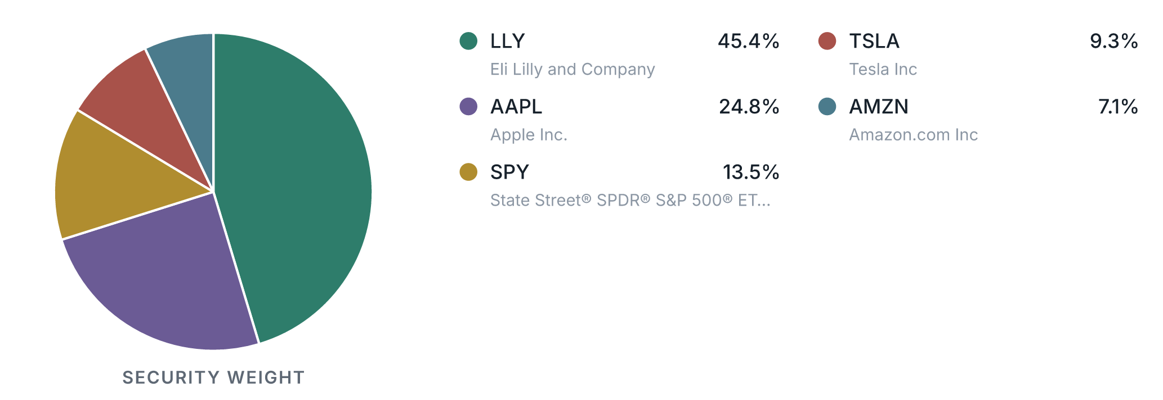
The portfolio shows a high level of concentration across the available position or exposure measures.

Current portfolio vs proposed strategy
The proposed strategy introduces a higher estimated level of portfolio risk.
Comparable risk measures indicate a higher overall estimated risk profile for the proposed strategy.
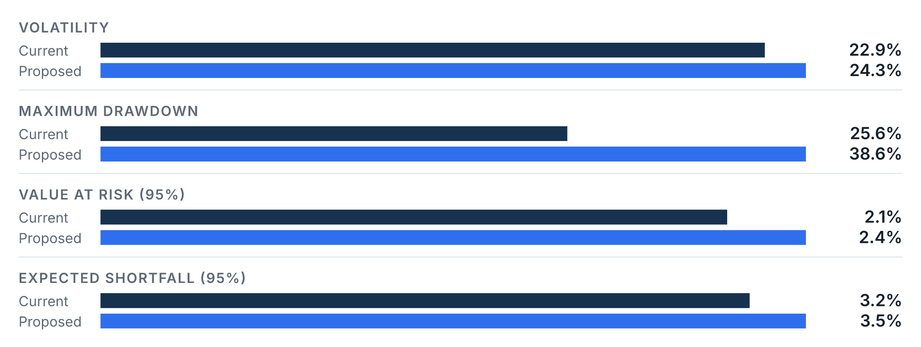
The higher risk estimate should be considered as a distinct characteristic of the proposed strategy.
The available evidence does not support a uniform improvement in diversification.

Understanding potential downside
Measure | Basis | Current | Current impact | Proposed | Proposed impact
Maximum drawdown | Observed period | 25.6% | −$717,560 | 38.6% | −$1,084,200
Value at risk (95%) | 95% confidence, 1 day | 2.1% | −$58,976 | 2.4% | −$66,383
Expected shortfall (95%) | 95% confidence, 1 day | 3.2% | −$89,419 | 3.5% | −$97,160

How the portfolio would change
The proposed strategy meaningfully reshapes the portfolio's instrument mix.
At least one instrument-type category changes by a material share of the portfolio; the composition below reflects that shift.
Category | Current | Proposed | Change
Stocks | 86.5% | 60.0% | -26.5%
ETFs | 13.5% | 40.0% | 26.5%

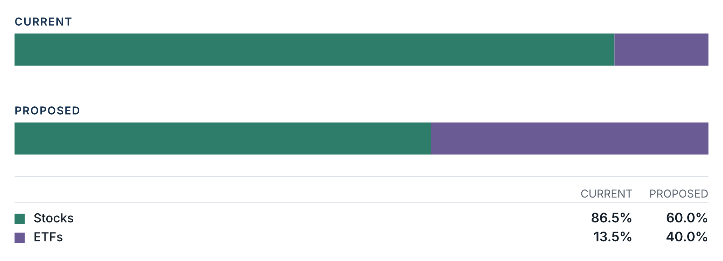

Where the portfolio is invested
Sector exposure shifts across the portfolio's classified holdings.
Authoritative sector classifications cover enough of both portfolios to compare sector weights directly; the comparison below reflects only the classified share of each portfolio.
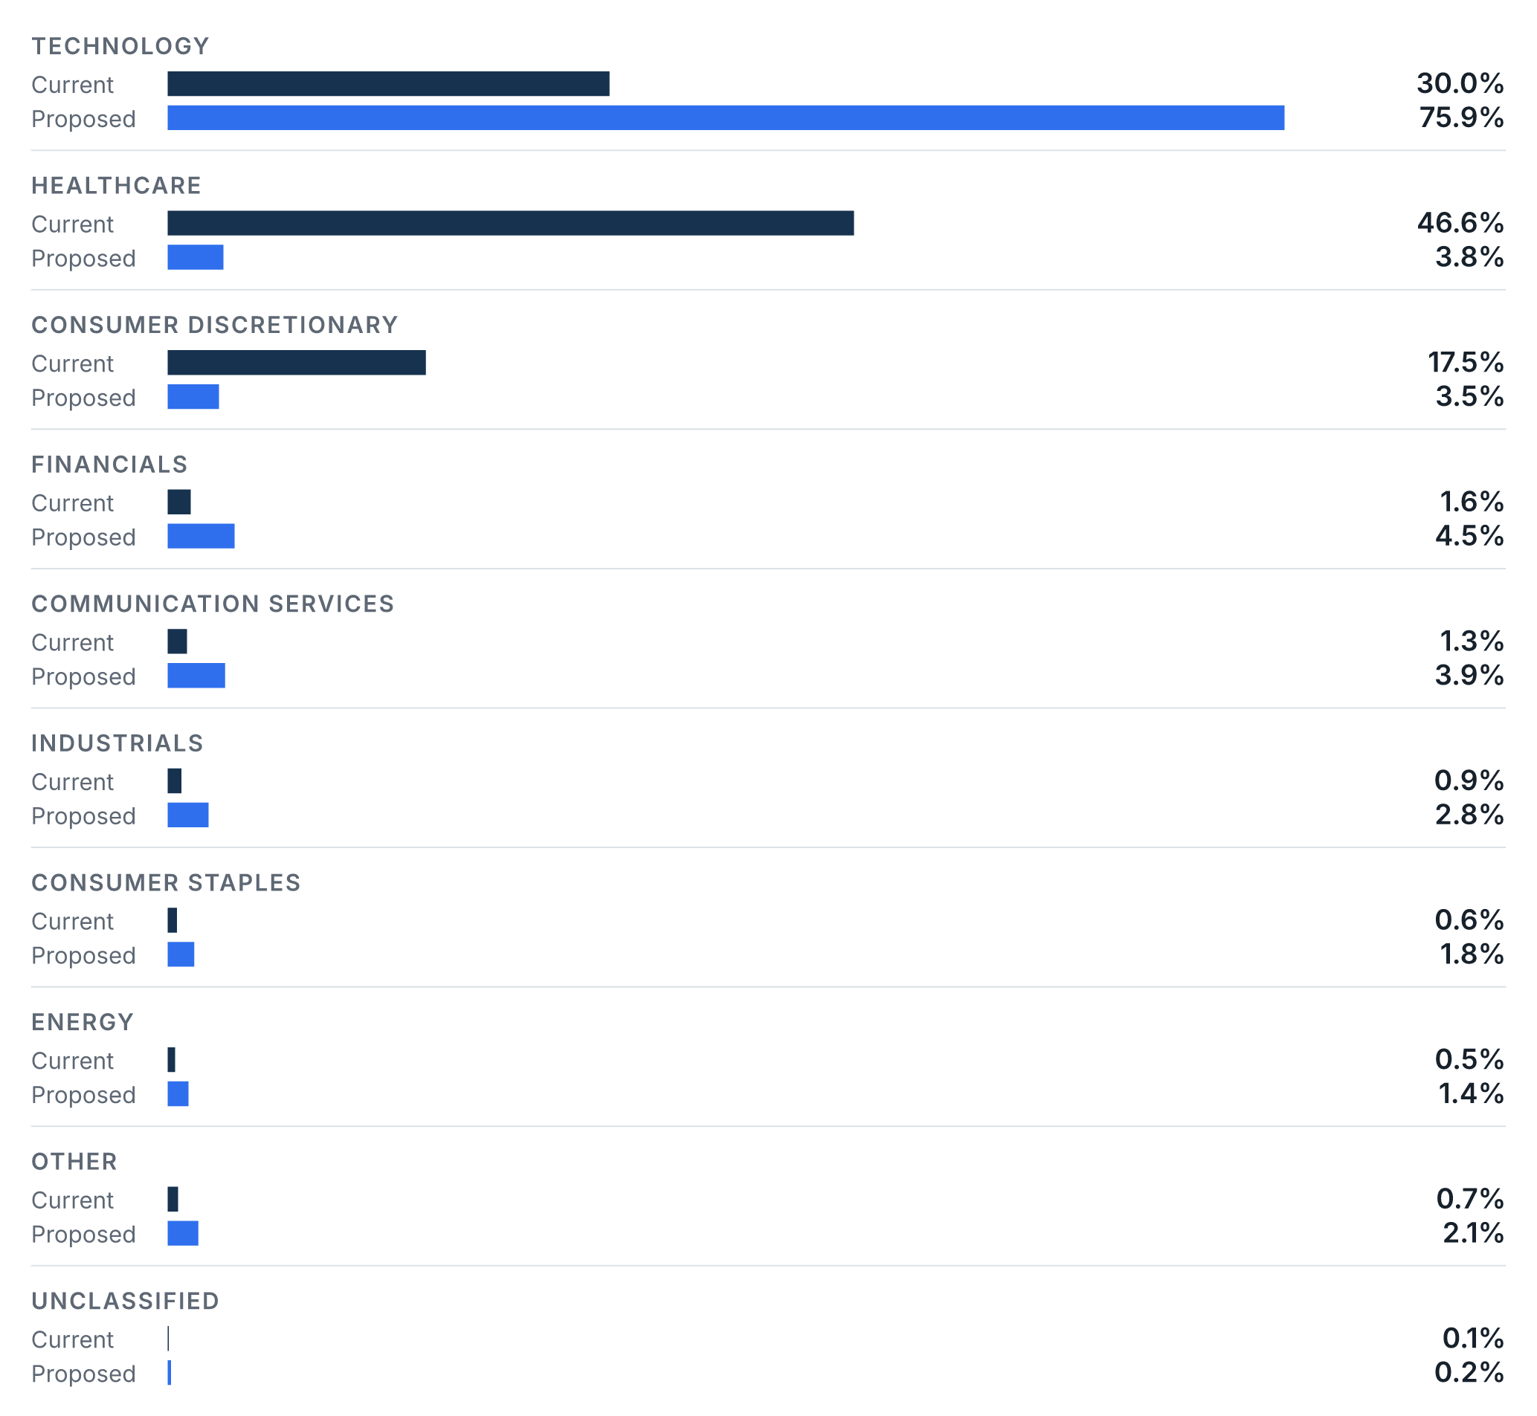

How the portfolios have behaved
Over the comparable measurement period, the proposed strategy's return measure is materially lower; this comparison does not imply future results.
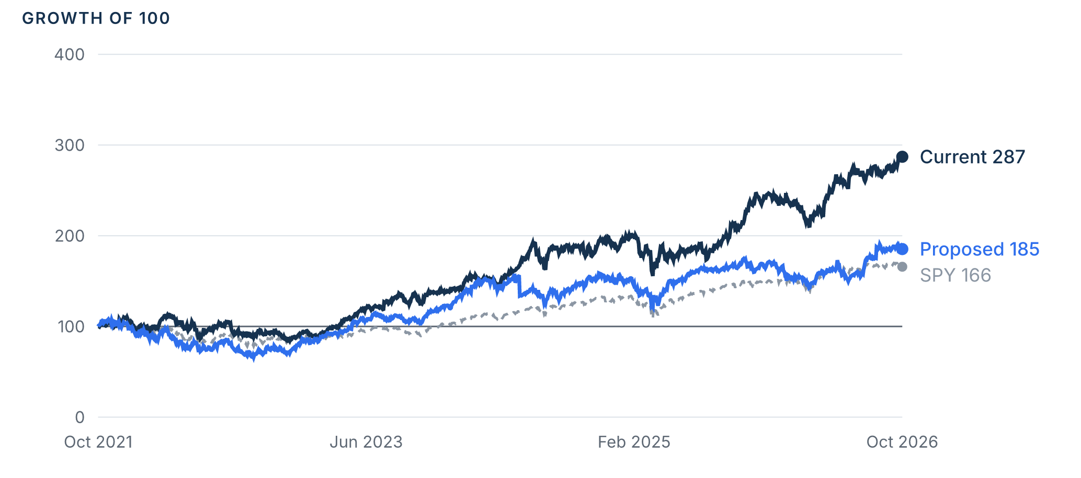
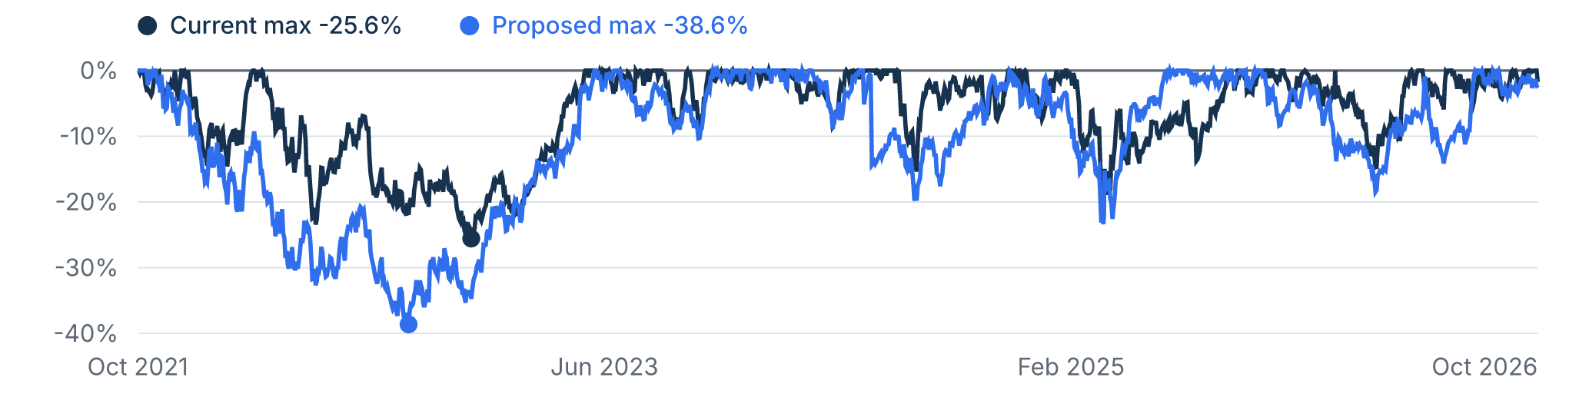
Metric | Current | Proposed
Cumulative return | 187.1% | 85.3%
Annualized return | 23.6% | 13.2%
Maximum drawdown | -25.6% | -38.6%

The recommended strategy
Core Model
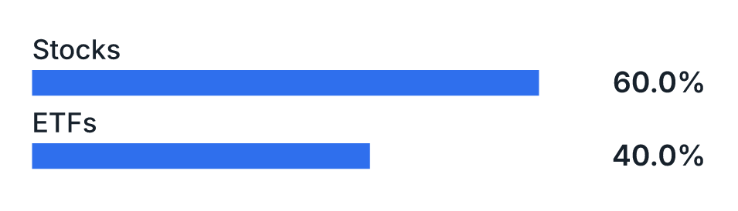
Attribute | Value
Strategy type | Model portfolio
Benchmark | QQQ
Rebalance policy | Monthly
Advisory fee | 2.00%

Methodology and disclosures
Past performance does not guarantee future results. Analytics are estimates computed from the data available when this proposal was prepared.
Item | Detail
Current methodology | Current Holdings Backtest
Proposed methodology | Model Portfolio Backtest
Measured period | 2021-10-28 to 2026-10-23
Observations | 1251
Fee basis | Gross
Benchmark | SPY
Risk measurement basis | Historical VaR / Expected Shortfall · 95% confidence · 1-day horizon
Comparison policy version | 1
Calculated | 2026-10-26

Current portfolio holdings
Symbol | Security | Direction | Asset class | Sector | Value | Weight
LLY | Eli Lilly and Company | Long | Stock | Other | $1,273,460 | 45.4%
AAPL | Apple Inc. | Long | Stock | Technology | $695,450 | 24.8%
SPY | State Street® SPDR® S&P 500® ETF Trust | Long | ETF | Financials | $379,985 | 13.5%
TSLA | Tesla Inc | Long | Stock | Consumer Cyclical | $260,554 | 9.3%
AMZN | Amazon.com Inc | Long | Stock | Consumer Cyclical | $198,400 | 7.1%

Proposed strategy holdings
Symbol | Security | Asset class | Sector | Weight
SPY | SPY | ETF | — | 20.0%
CRM | CRM | Stock | Technology | 20.0%
MSFT | MSFT | Stock | Technology | 20.0%
VOO | VOO | ETF | — | 20.0%
NVDA | NVDA | Stock | Technology | 20.0%

